Chapter 16, Solution 49.

Find i_{o}(t) for t > 0 in the circuit in Fig. 16.72.

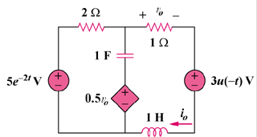

Figure 16.72
For Prob. 16.49.

Solution

We first need to find the initial conditions. For , the circuit is shown in Fig. (a).

(a)

3 V

2
+

i_{o}

1 H

+

V_{o}/2

1 F

+

V_{o}

1
To dc, the capacitor acts like an open circuit and the inductor acts like a short circuit. Hence,
,

We now incorporate the initial conditions for as shown in Fig. (b).

(b)

-1 V

2

+

I_{o}

+

V_{o}/2

1/s

+

V_{o}

1
+

2.5/s

s
+

5/(s + 2)

I₁

I₂

For mesh 1,

But,
(1)

For mesh 2,
(2)

Put (1) and (2) in matrix form.

,

Equating coefficients :

:
:
:

Solving these equations leads to
, ,

